[Entity Relationship Modeling (panopto.com)](https://wgu.hosted.panopto.com/Panopto/Pages/Viewer.aspx?id=bae03e4f-4a5f-44ca-ae59-ca2bf66ce2f1)

[Normalization Webinar 030617 (panopto.com)](https://wgu.hosted.panopto.com/Panopto/Pages/Viewer.aspx?id=2826a49c-cd20-493a-ab1f-20684316792d)

[Western Governors University | Udemy Business](https://wgu.udemy.com/home/my-courses/learning/)

[(84) WGU Data Management Foundations D426 V2 FlashCard Review Pt5 - YouTube](https://www.youtube.com/watch?v=nBesyb_kfWA&list=PL5pf-_j00XrU7x27Ql44a0Sv075X8YtrJ&index=5)

[(84) WGU Data Management Foundations D426 V2 FlashCard Review Pt5 - YouTube](https://www.youtube.com/watch?v=nBesyb_kfWA&list=PL5pf-_j00XrU7x27Ql44a0Sv075X8YtrJ&index=5)

**D426 V2 - Data Management Foundations - Some tips for how I passed this class.**



* [Database Design - YouTube](https://www.youtube.com/playlist?list=PL_c9BZzLwBRK0Pc28IdvPQizD2mJlgoID)
* <https://lrps.wgu.edu/provision/71492681>
* <https://wgu.hosted.panopto.com/Panopto/Pages/Viewer.aspx?id=bae03e4f-4a5f-44ca-ae59-ca2bf66ce2f1>
* <https://www.w3schools.com/sql/default.asp>
* <http://www.lynda.com/MySQL-tutorials/MySQL-Essential-Training/139986-2.html>
* <https://www.wisc-online.com/learn/computer-science/it-database>
* <https://www.linkedin.com/learning/programming-foundations-databases-2/normalization-2?u=2045532>
* <https://westerngovernorsuniversity-my.sharepoint.com/:w:/g/personal/maria_schenk_wgu_edu/EaOypS0-xdxBnVv0qtwfkfsBc57Wuy8-1SZl12YDEHipmQ?e=2XdQp2>
* <https://westerngovernorsuniversity-my.sharepoint.com/:w:/g/personal/maria_schenk_wgu_edu/ERmmjtuXEO9KuLMQEMU3heMBHRYaOJnr1T9dkWYdhq66tg?e=a3efyg>
* <https://protect-us.mimecast.com/s/YbTuCADX0PSZQl0qMSGfJW6?domain=youtube.com>
* <https://westerngovernorsuniversity-my.sharepoint.com/:w:/g/personal/maria_schenk_wgu_edu/EUBedPiC7BhCkSpTAj32c9oByoS2s_U2XKo843olFX6W5w?e=QFALoC>
* <https://lrps.wgu.edu/provision/71492681>
* <https://www.lucidchart.com/pages/er-diagrams>
* [ER Diagram (ERD) - Definition & Overview | Lucidchart](https://www.lucidchart.com/pages/er-diagrams)
* <https://learndatamodeling.com/blog/supertype-and-subtype/>
* <https://westerngovernorsuniversity-my.sharepoint.com/:w:/g/personal/maria_schenk_wgu_edu/EZ0f7dwEp_xDhdt-8_G60KkBSC1_sU2zmx_rH4Hul5qpGw?e=dzW1th>
* <https://www.lucidchart.com/pages/er-diagrams>
* <https://learndatamodeling.com/blog/supertype-and-subtype/>
* <https://drive.google.com/file/d/1U68CpBfKkkgvViNUlIe738S_ZjrUrMIj/view?usp=sharing>

Okay, so I passed this class tonight after nearly 3 weeks (for reference, I am averaging 4-5 days per class, I already work in the Software Engineering field).

I failed it the first time by two questions. This class is DENSE with information. It really should be two classes in my opinion with SQL Statements and Database Design. Nonetheless, it isn't. And the V2 of this course is very new. There is very little info out there about this version.

The two OA's I took were fairly different and had very few of the exact same questions and they covered some different areas. The first I felt didn't line up with the PA at all, the second definitely did. So whatever version of this test you take may determine the difficulty. I felt the second one I took was much easier. Take note, the questions are worded much differently than they are on the PA.

**DO NOT MAKE THE MISTAKE OF STUDYING C175 MATERIAL FOR THIS COURSE IF YOU ARE IN V2. IT WILL WASTE MORE OF YOUR TIME THAN IT WILL HELP.**

Good luck. I hated this class so much and I hope you have to suffer a little less than I did.

**If I remember additional material on the OA's, I will update this. My brain is fried at the moment.**

Here are some tips:

- Don't spend too much time practicing writing SQL statements. There were two syntax questions on my first test and two on the second. This is all about definitions. It wouldn't hurt to print all of the definitions from ZyBooks which you can do through the content explorer.

- Do know the very basic syntax and what order it goes in.

-My first OA had several questions about SQL Sublanguages and what each do, the second had none.

-My first OA had several questions about Data Normalization and Normal Forms/Boyce Codd, My second had none.

- Both OA's had multiple questions surrounding Cardinality

- Both had several questions surrounding key types

-Both had several questions surrounding data types

-There were no questions from the Business Intelligence material on either OA I had

- Both had several questions surrounding relationships (1-1, one-to-many, etc.)

- Both had a couple of questions about Crows Foot Notation

- Both had a few questions about indexes

- Both had a couple of questions about the query processor and transaction manager

- One of the questions on my first OA asked something about a SQLstate error.

- Both had a question about TRIM and LTRIM

- Both had a few questions about design stages

- Both had a couple of questions about aggregate functions

- Both had a couple of questions about joins

- Both had a few questions about attributes

- Both had a couple of questions about the syntax and function of ALTER, DROP, CHANGE, DELETE

- My second OA had two basic questions about MongoDB (hint: its a noSQL database, its designed for big data, and it is open source)

- My first OA had one question about when you would use an Artifical Key

Additionally, I have attached a SQL Cheatsheet I have been using for awhile, it covers a lot of things on this exam and it should help.

**Just passed D426 (V2) Data Management – Foundations OA!!!**



First attempt pass, thank god. This felt like a real celebration. Can't imagine D427 being more difficult.

Third class of my first semester. D426 was a real monster for me, total slog. Much more difficult than D315 Network and Security foundations, and D278 Scripting and Programming foundations. Primarily because it's just not engaging.

I'm sure the difficulty in part is due to the fact it's the first course I've had very little exposure to the content, MySQL and databases. Most of the other courses in WGU's BSCS program I've had some exposure to at CC but d426 was a cold break.

This course is **incredibly** definition heavy without much interactivity. As others have stated, should really be broken up into 2 courses. It's made even more difficult by the fact that the content is really dry and quite dense (zybooks is literally a few hundred pages long). I spent about 4-8hrs per day about 5 days a week over ~2 weeks completing this course full time. Primarily raw dogging zybooks (which I've had few complaints with till this course). Actually going through, taking notes, and completing all the problems.

I feel that this content could be dramatically improved with more interactivity. It's difficult to remember the material without creating a working model in your brain of the inter-related pieces. Without reference points it's a bit like trying to shovel your way out of waist deep quicksand with your bare hands.

Personally found that installing the MySQL community addition, creating small tables, playing with keywords and referencing what you read in zybooks makes it a much more enjoyable experience. There are tons of additional resources recommended by the course instructors. I used some of the suggested videos in the course material.

The PA did not line up 1-1 on my OA which has a pool of rotating questions. However, it did touch a lot of similar topics. Here's some resources I found useful:

-Zybooks: Despite the length and the snooze, it's the most relevant material for the test.

-Check the study plan for your D426 version

-This reddit post: <https://www.reddit.com/r/WGU/comments/13kp9hn/d426_v2_data_management_foundations_here_is_how_i/>

As stated in the above post: " DO NOT MAKE THE MISTAKE OF STUDYING C175 MATERIAL FOR THIS COURSE IF YOU ARE IN V2. IT WILL WASTE MORE OF YOUR TIME THAN IT WILL HELP. "

-W3 has a live SQL runtime environment, practicing with actual SQL statements. Much more engaging:

<https://www.w3schools.com/sql/default.asp>

-This quizlet is a life saver, totally worth the year subscription:

<https://quizlet.com/803779911/wgu-d426-v2-flash-cards/?funnelUUID=c676f51c-3aa0-450d-9952-89fb4fc60786>

-Bard or chatgpt for clarification and fact checking.

Creating your own Mnemonics (or using bard/chatgpt) for terms you need to remember. Many of the "systems" or definitions in zybooks are touched in the OA. Some more than others, check the previous reddit post.

MySQL documentation and community download:

<https://dev.mysql.com/doc/>

Good luck fellow IT schoolers . This course is tough, but it can be done. Remember to leave course feedback with WGU.

1. Quizlets :  
   <https://quizlet.com/787576252/wgu-data-management-foundations-d426-flash-cards/>

<https://quizlet.com/784159383/data-management-foundations-d426-wgu-flash-cards/>

**I passed Data Management Foundations And Here's Some Tips**



[Information Technology](https://www.reddit.com/r/WGU/search?q=flair_name%3A%22Information%20Technology%22&restrict_sr=1)

Now I spent some time studying for the exam in this course and there's things I would've done a bit more differently. Zybooks material is boring and it can slow you down. So I recommend material that is external from the provided Zybooks material because I found it more helpful and easier to learn and understand. I'll provide the resources that I suggest you use to study for the exam in this course and I'll write out a study guide for what you should study for.

1. Dr. Daniel Soper's videos on the topic are very helpful and it's still relevant information that would increase your understanding of the material covered in this course. Now you could watch his videos 1.5x or even 2.0x since it can be lengthy. Here's the link: [Database Lesson #1 of 8 - Introduction to Databases - YouTube](https://www.youtube.com/watch?v=4Z9KEBexzcM&list=PL1LIXLIF50uXWJ9alDSXClzNCMynac38g)
2. I recommend going to [sqlbolt.com](https://sqlbolt.com/) to learn how to use SQL interactively. I personally think it's a better use of time than to waste time on the Zybooks labs. You also have other websites out there such as [Codecademy.com](https://codecademy.com/) which provide detailed interactive SQL tutorials as well.
3. Now normalization is a bit tricky to understand because some material like Zybooks don't explain it clearly and simplistically. So I recommend watching a video from Decomplexify where he simplifies and breaks down what data normalization is because there are these questions on the exam and it could help you pass it if you do well on it. Here's the link to his video: [Learn Database Normalization - 1NF, 2NF, 3NF, 4NF, 5NF - YouTube](https://www.youtube.com/watch?v=GFQaEYEc8_8)

These are the resources that I have used to help pass this course. It'll help significantly in my opinion because Zybooks material can come off as overwhelming and boring. The actual objective assessment isn't that bad to begin with. It's very similar to the preassessment that you take in this course. I'd suggest you to study the preassessment and the material that is covered on there as well. There's actually 56 questions on the exam and the questions aren't tricky at all. It generally has 2 or 3 answers that are obviously wrong throughout the exam and logical thinking can help you succeed through this exam as well. Here's the study guide below so that you will be efficient with what material you will need to study for.

* Know the basic terminology of what data is and what it's used for. Know the history of how data was used historically before Database Management Systems. Know the history of what storage devices were used.
* Know the different files such as flat files, heap files, hashed tables, relational databases.
* Know the difference between structured and unstructured data.
* Know the differences between cardinality and modality.
* Know the differences between unary, binary, and ternary.
* Know what indexes are and how it's used.
* Know the differences betweent the keys such as primary key, candidate key, alternate key, foreign key.
* Know entity-relationship diagrams.
* Know referential integrity.
* Know the SQL Syntax since there's a lot of questions about it.
* Know the differences between first normal form, second normal form, and third normal form.
* Know the process and steps of (ETL) Extraction, Transform, and load.
* Know Affinity Grouping and Data Mining.

I did the quizzlet matching game alot here: [Quizzlet](https://quizlet.com/787576252/wgu-data-management-foundations-d426-flash-cards/" \t "_blank)

Also, I did watch Caleb Curry to understand more. He does a pretty good job of explaining things in laymans terms: [YouTube](https://www.youtube.com/playlist?list=PL_c9BZzLwBRK0Pc28IdvPQizD2mJlgoID)

# Data Management - Foundations - D426



\*This is for V2 only\*\*\*\*UPDATE. I have met with my instructor, who gave me some ideas for the test. He isn't allowed to see what is on the test. He also can't see what I got wrong or what areas to focus on.

If you have some more info to add to this posts that isn't available please dont hesitate to let me add or add to the comments. We search those too.

My OA didn't match the PA at all. I have passed the PA Several Times at this point. I take the PA before I take the test even though I Know it's trash money trash. I have heard some say it does match , others it doesn't. Which means there is different test versions. Heres what I gathered from myself and others since there is nothing really on this class cause it is new for SE Course. But you can google **Data Management - Foundations - and find older posts but be careful its not version 1 we are doing version 2 V2 9 Chapters of Zyebooks.**

**\*\*\*Study material\*\*\*\***

Flash Cards ( <https://www.cram.com/flashcards/data-management-foundations-d426-3-3-defines-primary-keys-v2-13590088> There are more flashcards for d426 honestly ran through these and found some stuff that may have helped. He has like three more for this class seems that they were broken down into 4ths. )

<https://quizlet.com/294474546/wgu-c175-pre-assessment-flash-cards/>

<https://quizlet.com/803779911/wgu-d426-v2-flash-cards/?funnelUUID=c676f51c-3aa0-450d-9952-89fb4fc60786>

**Flash Card Review On Video:**

<https://www.youtube.com/playlist?list=PL5pf-_j00XrU7x27Ql44a0Sv075X8YtrJ>

Definition Heavy (A lot of people were talking about the definitions being important. )

(Cardinality came up) - See below

"**But definitely make sure you know Normalization (1NF, 2NF, 3NF, BCNF), Cardinality, Aggregate Functions, Indexes and Table Structures, Crows Foot Notation, Database Design stages, SQL Sublanguages, and all the key types." - see below for alot of these.**

Currently going through.

**Zybooks(Course book)** - Is based on Test

**Here is a SQL Cheat Sheet.** <https://ibb.co/yggFzgm> - I have been giving this multiple times.

Caleb -Video is actually well versed watched two chapters. This will build on understanding of what certain definitions are. <https://www.youtube.com/watch?v=WttoAlS__8k&list=PL_c9BZzLwBRKC2PJwLFxc2y6cyXYYQzj3>

Another older version of his videos <https://www.youtube.com/watch?v=h0j0QN2b57M&list=PL_c9BZzLwBRK0Pc28IdvPQizD2mJlgoID>

Dr Daniel Snoper- MEH, 🫤 Didn't really retain much at all. Was expecting good things due to multiple mentions. But everyone learns different.

<https://www.youtube.com/watch?v=4Z9KEBexzcM&list=PL1LIXLIF50uXWJ9alDSXClzNCMynac38g>

**Quick Video: Five minutes recap of SQL**

<https://www.youtube.com/watch?v=vkhjO7fc78g>

**Key Types:** **(Imagine a SQL DB W/ Columns for [Student ID/Student Name/Phone #/DOB])**

[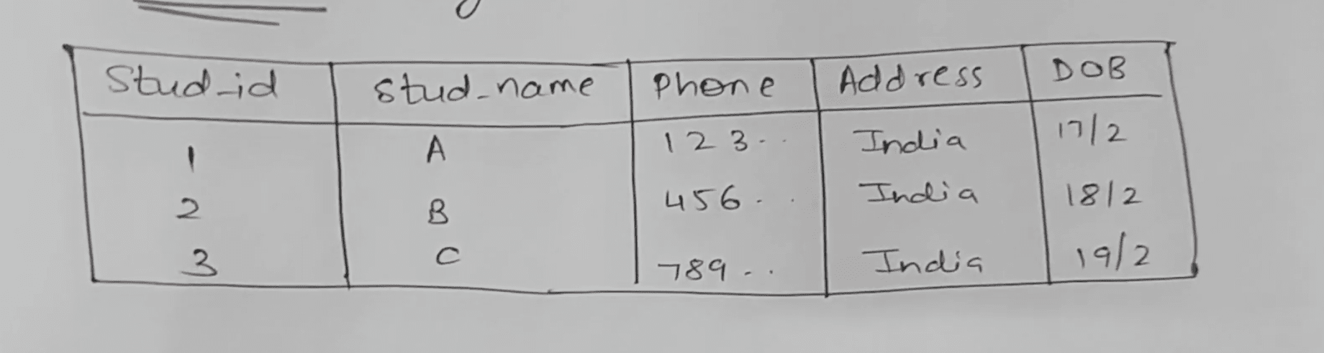](https://preview.redd.it/goln00sd7b1b1.png?width=1840&format=png&auto=webp&s=3c979a3c041fa44791cac57fb430f0537f36e0b2)

Use this DB for below Follow Youtube link below for actual video

**Candidate Key** - \*\*Example Student ID / Phone # -\*\*There can be more than one candidate key

**Super Key** - Set of attributes that can uniquely identify each record

<https://youtu.be/UZE18cfk_3k>

**Primary Key** - Can only be one key -Most appropriate candidate key Example: **Student ID**

[**https://www.dotnettricks.com/learn/sqlserver/different-types-of-sql-keys**](https://www.dotnettricks.com/learn/sqlserver/different-types-of-sql-keys) **(Screen Shot)**

[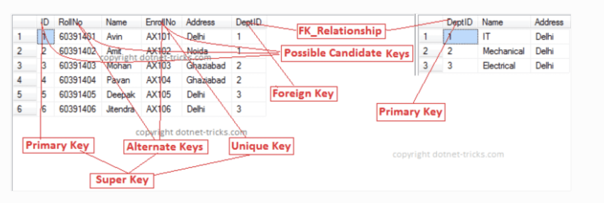](https://preview.redd.it/psuq7k9a7b1b1.png?width=1526&format=png&auto=webp&s=78324e56d188b78fae02f4e78757f7c926cc58a0)

Different SQL Keys

**A unique key** -is a set of one or more fields/columns of a table that uniquely identify a record in a database table. It is like a Primary key but it can accept only one null value and it can not have duplicate values. For more help refer to the article

**Foreign Key** -is a field in a database table that is the Primary key in another table. It can accept multiple nulls and duplicate values. For more help refer to the article

**An Alternate key** -is a key that can work as a primary key. Basically, it is a candidate key that currently is not a primary key.

In other words, the alternate key is a column or collection of columns in a table that can uniquely identify each row in that table. Every table of the database table can have multiple options for a primary key to be configured but out of them, only one column can be set as the primary key. All the keys which are not primary keys are called the alternate keys of that table.

Excerpt (<https://www.dotnettricks.com/learn/sqlserver/different-types-of-sql-keys>)

Advice from **[ApatheticWithoutTheA](https://www.reddit.com/user/ApatheticWithoutTheA/" \t "_blank)** **(Thank you)**

But definitely make sure you know Normalization (1NF, 2NF, 3NF, BCNF), Cardinality, Aggregate Functions, Indexes and Table Structures, Crows Foot Notation, Database Design stages, SQL Sublanguages, and all the key types.

SubLanguages

* **DDL- (Data Definition Language)** Manipulate Tables Create, Alter, Drop, Truncate
* **DML-** **(Data Manipulation)** Insert/Update/Delete. Used to modify DB all form changes in DB
* **DCL** -**(Data Control Language)** Manages access gives takes user privileges
* **TCL/DTL -(Transaction Control Language)** Can only use w/ DML commit/rollback /save point

Aggregate Function - Min Max returns a minimum or maximum

Types of Joins-

<https://www.dotnettricks.com/learn/sqlserver/different-types-of-sql-joins>

Which Join slots only matching L&R Table rows - Innerjoin

Where Dog.KennelID=KennelID This is Equijoin

= type of join uses this operator Equijoin

Join combines two tables without comparing columns -Cross Join

**Indexes**: This video was pretty good. <https://www.youtube.com/watch?v=fsG1XaZEa78>

**Normal Form (1st normal form to fifth normal form)**

1NF (First Normal Form):

* Each column in a table should contain only atomic values (indivisible values) and not contain repeating groups.
* Each table should have a primary key that uniquely identifies each row.
* Mixing different data types within the same column is not allowed.

2NF (Second Normal Form):

* Every non-key attribute (column) in a table must be functionally dependent on the entire primary key.
* If a table has a composite primary key (consisting of multiple columns), each non-key attribute should depend on the entire composite key, not just a part of it.

3NF (Third Normal Form):

* Every non-key attribute should depend on the key (primary key), the whole key, and nothing but the key.
* Transitive functional dependencies should be eliminated. In other words, if A depends on B and B depends on C, then A should not depend on C.

BCNF (Boyce-Codd Normal Form):

* Similar to 3NF, but specifically applies to tables with only single-valued dependencies.
* It ensures that every determinant (a column or set of columns that uniquely determines the values in another column) is a candidate key.
* It eliminates all dependencies other than those based on candidate keys.

4th and 5th NF and recap of all others <https://www.youtube.com/watch?v=GFQaEYEc8_8>

Cardinalities- Max # of times instance in 1 entity can be related to instance in another entity.

Modality - Min # of times that an instance can be related to an instance in another entity.

Binary relationship - One to many - many to many- 0 to many

Unary Relationship - One to One - O to 1 - many to many - 0 to many

Deletion anomaly -

Insertion anomaly -

**Design Data Base Stages (In This Order)**

* The **analysis** phase specifies database requirements without regard to a specific database system. Requirements are represented as entities, relationships, and attributes. An entity is a person, place, activity, or thing. A relationship is a link between entities, and an attribute is a descriptive property of an entity.
* The **logical design** phase implements database requirements in a specific database system. For relational database systems, logical design converts entities, relationships, and attributes into tables, keys, and columns
* The **physical design** phase adds indexes and specifies how tables are organized on storage media. Ex: Rows of a table may be sorted on the values of a column and stored in sort order. Physical design is specified with SQL statements such as CREATE INDEX and, like logical design, is specific to a database system.

Aggregate Functions

An **aggregate function** processes values from a set of rows and returns a summary value. Common aggregate functions are:

* **COUNT()** counts the number of rows in the set.
* **MIN()** finds the minimum value in the set.
* **MAX()** finds the maximum value in the set.
* **SUM()** sums all the values in the set.
* **AVG()** computes the arithmetic mean of all the values in the set.

**Fanout**

**Joins**

1. Inner Join:

* Syntax: SELECT \* FROM table1 INNER JOIN table2 ON table1.column = table2.column;
* The inner join returns only the matching rows from both tables based on the specified condition.

1. Left Join (or Left Outer Join):

* Syntax: SELECT \* FROM table1 LEFT JOIN table2 ON table1.column = table2.column;
* The left join returns all the rows from the left table (table1) and the matching rows from the right table (table2). If there are no matches in the right table, NULL values are returned for the columns of the right table.

1. Right Join (or Right Outer Join):

* Syntax: SELECT \* FROM table1 RIGHT JOIN table2 ON table1.column = table2.column;
* The right join returns all the rows from the right table (table2) and the matching rows from the left table (table1). If there are no matches in the left table, NULL values are returned for the columns of the left table.

1. Full Join (or Full Outer Join):

* Syntax: SELECT \* FROM table1 FULL JOIN table2 ON table1.column = table2.column;
* The full join returns all the rows from both tables. If there are no matches in either table, NULL values are returned for the columns of the non-matching table.

1. Cross Join (or Cartesian Join):

* Syntax: SELECT \* FROM table1 CROSS JOIN table2;
* The cross join returns the Cartesian product of both tables, meaning every row from the first table is combined with every row from the second table..

Join clauses are standard SQL syntax and supported by most relational databases. MySQL supports INNER, LEFT, and RIGHT JOIN but not FULL JOIN.

The **UNION** keyword combines the two results into one table

Databases: Know which one is open source, commercial etc.

[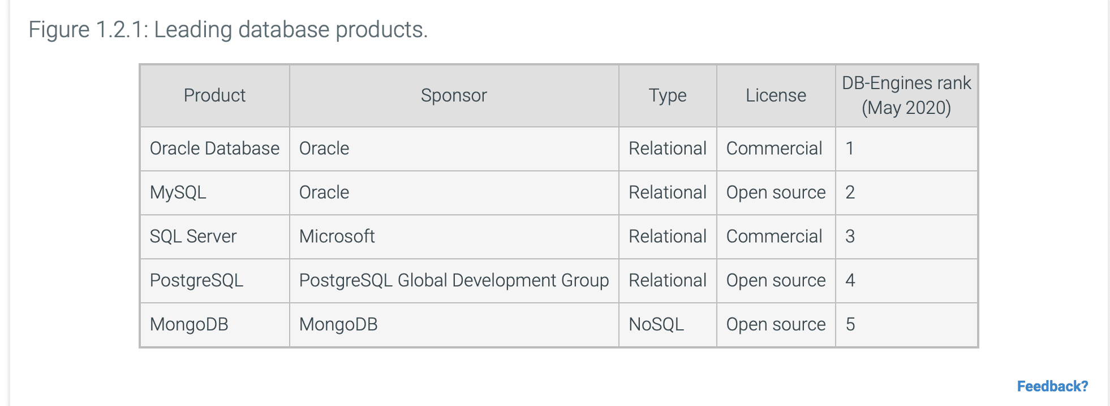](https://preview.redd.it/x7dn3raqfq1b1.png?width=1962&format=png&auto=webp&s=b852463f7dcc7540d9b73f350a10fef6382d1dfc)

<https://learn.zybooks.com/zybook/WGUD426v2/chapter/1/section/2?content_resource_id=61820717>

Here is an excerpt from below on the OA advice:

"**But definitely make sure you know Normalization (1NF, 2NF, 3NF, BCNF), Cardinality, Aggregate Functions, Indexes and Table Structures, Crows Foot Notation, Database Design stages, SQL Sublanguages, and all the key types."**

I will continue to update. Not really sure what to study after failing except to just press in. Usually works eventually. I am over the fear of failing. I used to stress out. Sure I am annoyed by the waste of time it takes to take a test twice or three times. I just refuse to let the stress bother me, especially on a class that is poorly constructed and managed. You shouldn't stress, just do your part to pass. I had only failed one test out of several classes before this test.

I hope This Blesses someone.

From <https://www.reddit.com/r/WGU/comments/13kp9hn/d426_v2_data_management_foundations_here_is_how_i/> Here are some tips: (Can also click the link)

- Don't spend too much time practicing writing SQL statements. There were two syntax questions on my first test and two on the second. This is all about definitions. It wouldn't hurt to print all of the definitions from ZyBooks which you can do through the content explorer.

- Do know the very basic syntax and what order it goes in.

-My first OA had several questions about SQL Sublanguages and what each do, the second had none.

-My first OA had several questions about Data Normalization and Normal Forms/Boyce Codd, My second had none.

- Both OA's had multiple questions surrounding Cardinality

- Both had several questions surrounding key types

-Both had several questions surrounding data types

-There were no questions from the Business Intelligence material on either OA I had

- Both had several questions surrounding relationships (1-1, one-to-many, etc.)

- Both had a couple of questions about Crows Foot Notation

- Both had a few questions about indexes

- Both had a couple of questions about the query processor and transaction manager

- One of the questions on my first OA asked something about a SQL state error.

- Both had a question about TRIM and LTRIM

- Both had a few questions about design stages

- Both had a couple of questions about aggregate functions

- Both had a couple of questions about joins

- Both had a few questions about attributes

- Both had a couple of questions about the syntax and function of ALTER, DROP, CHANGE, DELETE

- My second OA had two basic questions about MongoDB (hint: its a noSQL database, its designed for big data, and it is open source)

- My first OA had one question about when you would use an Artificial Key

**Another Test Taker**

"**But definitely make sure you know Normalization (1NF, 2NF, 3NF, BCNF), Cardinality, Aggregate Functions, Indexes and Table Structures, Crows Foot Notation, Database Design stages, SQL Sublanguages, and all the key types." - see below for a lot of these.**

Additionally, I have attached a SQL Cheatsheet I have been using for awhile, it covers a lot of things on this exam and it should help.

If there is something that I can add. Let me know in comments or chat. I will add. I want this to be the one stop post for this class. So if you have something to add. Please let me know.

\*\*\*About the course.\*\*\*\*

\*\*\*Many people, whether experienced or inexperienced, often feel that the class they are taking doesn't match their expectations. Sometimes, even if they know something is wrong, they just pass the class and move on. If the class is poorly structured, you should look for the course feedback link in the right-hand corner of the course page. Login to the course platform, go to the class, and share your feedback about what went wrong. Considering the number of complaints, it's likely that some adjustments will be made to the course based on the feedback received.

\*\*\*Update on this. I feel at this point WGU is fully aware of the issue.\*\*The chatter on this course has majority complaints alone on the issue with the class material for learning. The instructor has no access to the test, so they cant tell you anything except stock answers. Teachers teach not point, but Zybooks eliminates that channel. I would have at least have had a conversation to see where your head knowledge was, go over some sample questions that I sent you by email(read like a test scenario) to see if you were dissecting the question properly and went from there diagnosing the issue. I'm not a teacher either just a business man using common sense, problem solving and applying it to a teaching technique. I can only assume the following. If I am wrong help me understand your stance.

1. They don't care because it isn't negatively affecting them and there is really nothing you can do about it.
2. There isn't enough people failing this course the first time to be a problem. \*\*People who pass on the first try for the most part don't like the course outline and comment this as well. But honestly most of us just don't have the spare time to write or say anything. We are trying to level up with the degree we have.